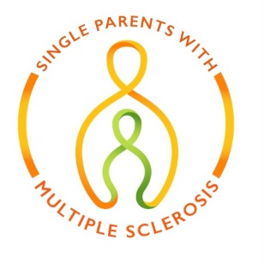
Application
Name:
Address:
Phone:
Email:

Living with MS? (circle one): Yes No
** Include a letter from your doctor stating you are being treated for Multiple Sclerosis.
Single Parent? Yes No
Children & Ages:

Work Status (circle one): Retired Full-Time Part-Time Disability
Annual Income:
Income Sources:

Support Needed (circle all that apply)
Holiday Pick Me Up Equipment Home Repairs
Food Financial Aid Other

Describe Your Situation and Request for Support

